Exam Programming Practicum 01/09/2014, 09.00 - 12.00

- You cannot use any material you bring yourself, but all relevant code is provided after the three questions.
- Please start every question on a new sheet.
- Good luck!!!
Question 1: True or False. (5 points)
For each of the statements below, indicate whether they are correct or not. No motivation required.
- In the worst case, the time complexity of finding an element in a binary search tree containing N elements is O(N).
- Any unbalanced tree of size n can be balanced in O(log n) rotations.
- In a graph G=(V,E) if a vertex v in V is visited during level k of a breadth first search from source vertex s in V, then every path from s to v has a length of at most k.
- DFS will take O(V²) time on a graph G=(V,E) represented as an adjacency matrix.
- Suppose T is a Red-Black-Tree containing natural numbers. If S is exactly the same tree as T, except that each element has a value that is twice the value of the corresponding element in T, then S is also a Red-Black-Tree.

Question 2: Recursion (4 points)
A number is an integer multiple of 9 if the sum of its digits is a multiple of 9. Hence, this is a recursive definition. Implement a method boolean isMultipleOf9(int number) to test for this.
You can use the following method that converts an integer number into a LinkedList of its digits: LinkedList integerToDigits(int number).
For example, integerToDigits(128) returns a linked list [1, 2, 8].
Your method can only return true or false if it gets a single digit number (or single element list) as input, otherwise it should make a recursive call. You can write multiple helper methods.

Question 3: Trees (7 points)

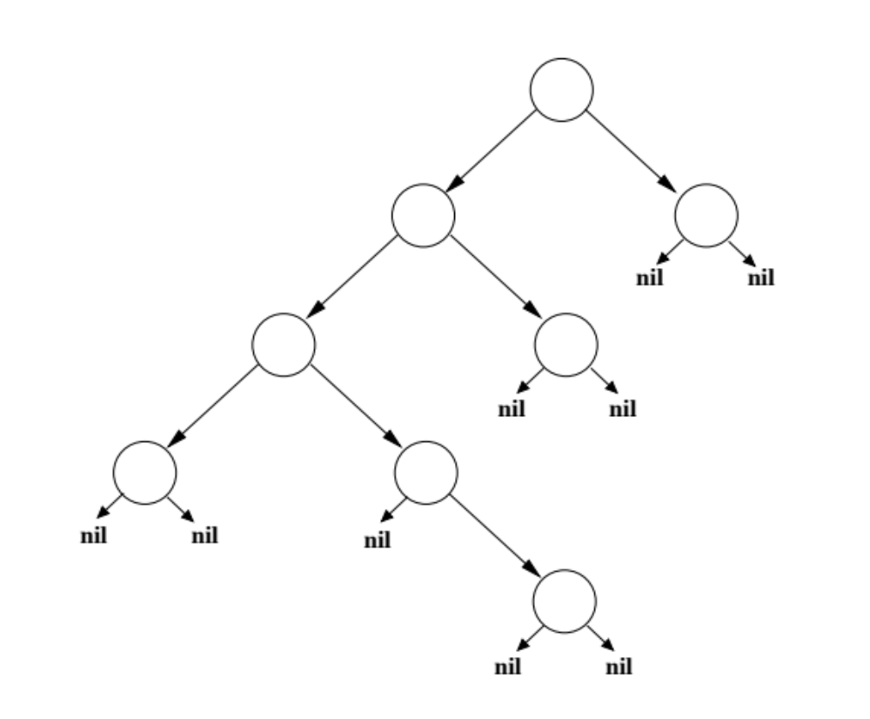
Consider the binary search tree given in the figure below.
- Give the binary search tree with the above structure that contains the elements 2,3,5,7,11,13,17 and 19.
- The nodes in this tree cannot be colored into a valid Red Black Tree. Give a proof for this statement.
- By applying a single rotation to the tree, it can be converted into a valid Red Black Tree. Which one?
- Implement a method that sums all the elements in a Red Black Tree (assume that the tree only contains integers).
- What is the time complexity of such a sum method?

Question 4: Graphs (3 points)
If A = (V1,E1) and B = (V2,E2) are two unweighted DAG’s and they have both the same set of vertices: V1=V2, implement A union B in the matrix representation.

Question 5: Linked Lists (6 points)
Since the elements of a linked list can be of any type, the elements can be Linked Lists as well. Consider for instance L1 = ((1,2),(3,4),(5,6)) to be a Linked List of 3 elements where the first element is a Linked List containing two elements: 1 and 2.
- Write the code to create the Linked List L1.
- Make a drawing showing the internal structure of the list.
- Consider L1 as defined above and let L2 =((a,b),(c,d),(e,f)). The result of “merging” L1 with L2, is that L1 is now the list ((1,2,a,b),(3,4,c,d),(5,6,e,f)). Give the implementation of this “merging” function, it cannot create a new Linked List, but only change pointers in the existing lists. You can assume that both L1 and L2 have the same length. BUT: the elements in L1 and L2 can be lists when an arbitrary length.
- What is the time complexity of the above method?

Provided Code

Linked List

public class LinkedList implements Comparable{

class ListElement
{
private Comparable el1;
private ListElement el2;

public ListElement(Comparable el, ListElement nextElement)
{
el1 = el;
el2 = nextElement;
}

public ListElement(Comparable el)
{
this(el,null);
}

public Comparable first()
{
return el1;
}

public ListElement rest()
{
return el2;
}

public void setFirst(Comparable value)
{
el1 = value;
}

public void setRest(ListElement value)
{
el2 = value;
}
}

protected ListElement head;
private int count = 0;

public LinkedList()
{
head = null;
}

public void addSorted(Comparable o)
{
// an empty list, add element in front
if(head == null) head = new ListElement(o,null);
else if(head.car().compareTo(o) > 0)
{
// we have to add the element in front
head = new ListElement(o,head);
}
else
{
// we have to find the first element which is bigger
ListElement d = head;
while((d.cdr() != null)&&(d.cdr().car().compareTo(o) < 0))
{
d = d.cdr();
}
ListElement next = d.cdr();
d.setCdr(new ListElement(o,next));
}
count++;
}

}

Binary Search Tree

public class Tree {

public class TreeNode implements Comparable {
protected Comparable value;
protected TreeNode leftNode;
protected TreeNode rightNode;

public TreeNode(Comparable v)
{
value = v;
leftNode = null;
rightNode = null;
}

public TreeNode(Comparable v, TreeNode left, TreeNode right)
{
value = v;
leftNode = left;
rightNode = right;
}

public TreeNode getLeftTree()
{
return leftNode;
}

public TreeNode getRightTree()
{
return rightNode;
}

public Comparable getValue()
{
return value;
}

}

protected TreeNode root;

public Tree()
{
root = null;
}

public void insert(Comparable element)
{
insertAtNode(element, root, null);
}

private void insertAtNode(Comparable element, TreeNode current, TreeNode parent)
{
// if the node we check is empty
if (current == null)
{
TreeNode newNode = new TreeNode(element);
// the current node is empty, but we have a parent
if (parent != null)
{
// do we add it to the left?
if (element.compareTo(parent.value) < 0)
{
parent.leftNode = newNode;
}
// or do we add it to the right?
else
{
parent.rightNode = newNode;
}
}
// the current node is empty and it has no parent, we actually have an empty tree
else
root = newNode;
} else if (element.compareTo(current.value) == 0)
{
// if the element is already in the tree, what to do?
}
// if the element is smaller than current, go left
else if (element.compareTo(current.value) < 0)
{
insertAtNode(element, current.getLeftTree(), current);
}
// if the element is bigger than current, go right
else
insertAtNode(element, current.getRightTree(), current);
}
public void traverse(TreeAction action)
{
QueueVector t = new QueueVector();
//Stack t = new Stack();
t.push(root);
while(!t.empty())
{
TreeNode n = (TreeNode)t.pop();
action.run(n);

if(n.getLeftTree() != null) t.push(n.getLeftTree());
if(n.getRightTree() != null) t.push(n.getRightTree());
}
}

}

Graph Matrix
public class MatrixGraph
{
private Matrix data;
private int nrNodes;

public MatrixGraph(int nrNodes)
{
data = new Matrix(nrNodes);
self.nrNodes = nrNodes;
}

public void addEdge(int from, int to, double w)
{
data.set(from, to, w);
}

public double getEdge(int from, int to)
{
return (Double)data.get(from, to);
}

}

